

Ostermalm vs Sodermalm

A battle for the best location for a new coffee shop in Stockholm



March 14, 2019

**Introduction**

Sweden is one of the top coffee drinking countries in the world. Stockholm is the capital of Sweden, and the most populous city. A company looking to expand its operations with a target of growing in Sweden, and in Scandinavia more generally (Scandinavian countries are all heavy coffee drinkers), will want to start in Stockholm.

Stockholm presents an ideal foothold in Sweden and Scandinavia more broadly for a coffee shop, as it is a large population center and a likely starting point for diffusion across the region. There are likely already incumbents, however, and so there is a threat of competition.

Ideal target locations would blend a combination of opportunity with this competitive threat.

The analysis will require balancing the costs and benefits of the various regions within Stockholm. Negative criteria should include competitive threats, including the number of pre-existing coffee shops, while positive criteria should include population and proximity to other venues.

The goal of this project is to determine which would be the best location for opening up a new coffee shop, between Ostermalm and Sodermalm, which are two central districts in Stockholm.

This project would be interesting to those wishing to get a foothold in the coffee market in Northern Europe. Specifically, this would help clarify what the best location would be for opening a coffee shop in Stockholm, with the aim that this first coffee shop would be the initial break-in for further expansion in the area.

**Data**

The data needed for this project includes location data within Stockholm as well as venue data from Foursquare.

Information on the boroughs in Stockholm can be obtained from Stockholm.se, including a list of boroughs and population. However, the location data is unavailable. This we pull from the Wikipedia pages from the respective boroughs of interest, in this case Ostermalm and Sodermalm.

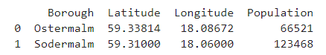

With the data on locations for the respective boroughs, we can then pull venue data from Foursquare. The below table shows a sampling of the data. The idea is to get an idea of the distribution of the data in terms of competitive forces vs attractions that would encourage more customers.

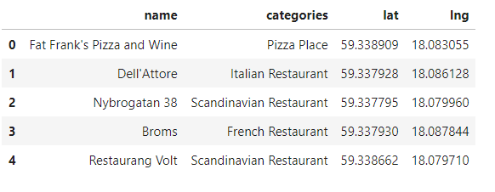

**Methodology**

Much of the methodology relies on downloading and classifying the data. The conclusion should ultimately be easy based on the comparison of competitive pressures vs attractions.

To that aim, we grab the data for both Sodermalm and Ostermalm and see what types of venues there are in each. Using that data, we go through and group them into essentially three baskets: competitive, attractions, and irrelevant.

For competitive threats, cafes, coffee shops and bistros are included. For attractions, bookstore, movie theaters, gyms, plazas, dance studios, food courts, theaters, boutiques, antique shops, opera houses, history museums, shoe stores, yoga studios, hotels, parks, stadiums, concert halls, furniture stores, theme parks, women’s stores, museums, boutiques, department stores, art museums, and offices. Everything else is considered neutral or irrelevant.

The map below illustrates this concept for Ostermalm, with competitive threats in red and attractions in blue.

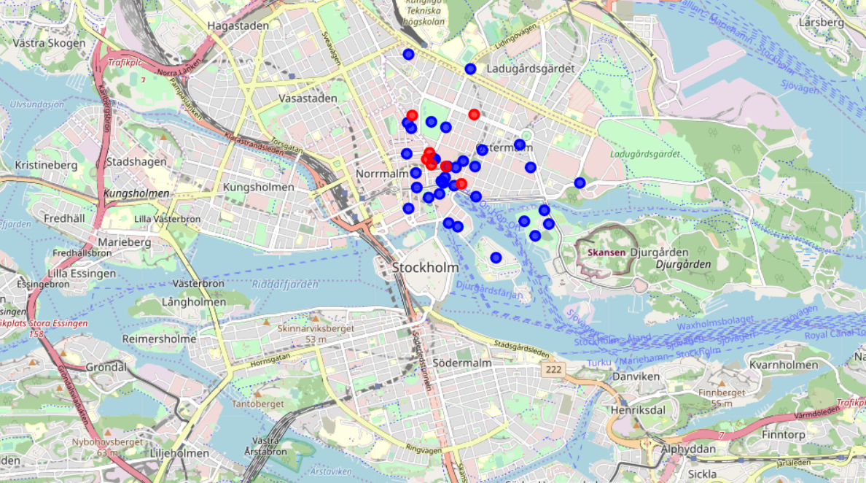

**Results**

Once the venues are downloaded, classified and tabulated we can compare the relevant stats. The table below illustrates that the competition is less for Ostermalm although the foot traffic is likely to be higher based on the number of attractions in the area.

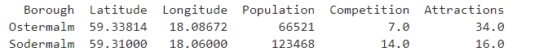

**Discussion**

There are a few potential issues that seem to crop up in the data, that may require further investigation:

1. The count of the relevant venues seems to be too small for a major European city, suggesting some venues may not be included or properly categorized
2. There may be further need to differentiate the attractions and give them different weightings. A museum may attract more visitors and potential customers than a shoe store for instance.

**Conclusion**

The immediate conclusion would be that Ostermalm is the better place to open a coffee shop. There is both less competition and more attractions to pull in potential customers